Enabling UNICODE FONT support on Windows

Step 1: (For System administrator)

A. Click on
Start → Settings → Control Panel → Regional Options
Select the “General” Tab (See Fig. 1 )
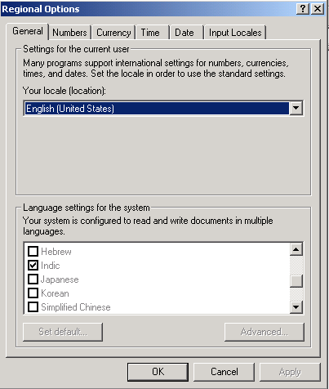
Fig. 1
B. In the “Language setting for the system” (See Fig. 1) scroll-down & select ‘Indic’
Checkbox.
Put Window 2000/ Window XP installer CD into the CD-ROM and then click ‘Apply’
C. After that REBOOT the system.

Step 2: (For normal User)

A. Click on
Start → Settings → Control Panel → Regional Options
Select the “Input Locales” Tab. (See Fig. 2)
Press “Add” button that is in “Installed input locales” box
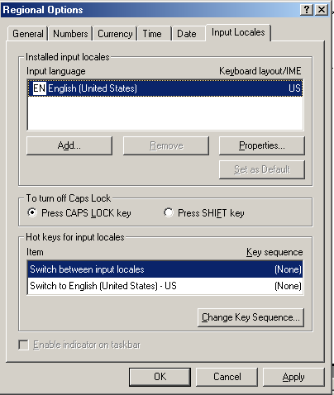
Fig. 2
After clicking the “Add” button “Add Input Locale” window (See Fig. 3) will open.

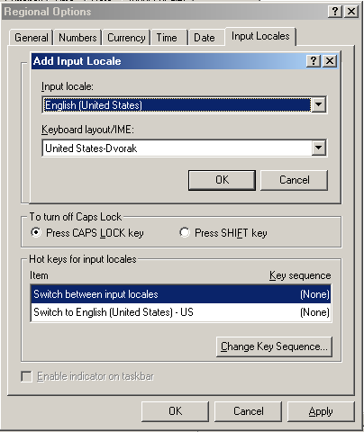
Fig: 3
If you want to choose Hindi Language then select ‘Hindi’ in “Input Locale” drop-down menu.
Make sure that in drop down menu “Keyboard layout/IME”, “Hindi” is selected. (See Fig. 4)
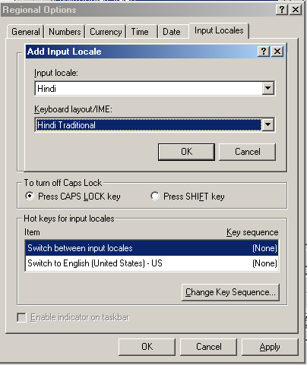
Fig : 4
Then click OK → Apply → OK

After doing all steps above you can see the language option in System tray (right side of task bar) (See Fig. 5).
By pressing “Alt + Shift” you can switch the language.
Fig. 5

